[**The Place For Free Online Training Courses**](https://www.free-online-training-courses.com/)

Top of Form

Bottom of Form

**Improve Your Career Prospects**

* [Home](https://www.free-online-training-courses.com/)
* [Office Software](https://www.free-online-training-courses.com/office-software-lessons/)
* [Learn Computer Skills](https://www.free-online-training-courses.com/learn-computer-skills-lessons/)
* [Website Building](https://www.free-online-training-courses.com/website-building/)
* [Business Tutorials](https://www.free-online-training-courses.com/business-tutorials/)
* [FaQ](https://www.free-online-training-courses.com/frequently-asked-questions/)

**Post navigation**

[**Enhancing Productivity**→](https://www.free-online-training-courses.com/enhancing-productivity/)

**Working with Spreadsheets**

**Open, close a spreadsheet application. Open, close spreadsheets.**

To start Calc, click on the ‘Start’ button on your Windows machine. Click on ‘All Programs’ and then go to the ‘LibreOffice’ folder in the list of all programs which gets displayed. Click on the ‘LibreOffice’ folder and then click on ‘LibreOffice Calc’. This will start the Calc application.

**Use the buttons below to navigate through the lesson**



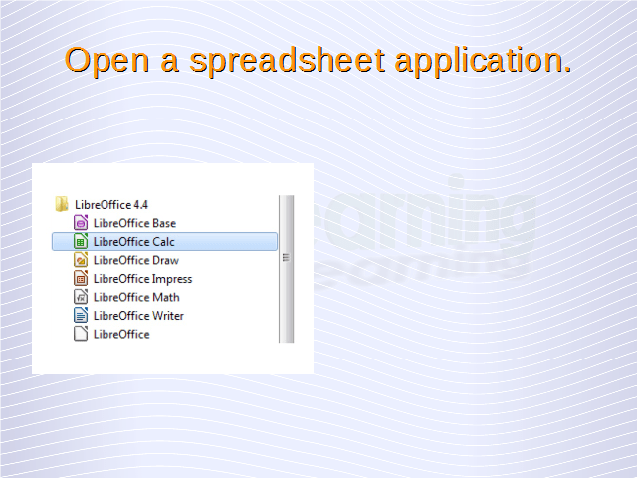

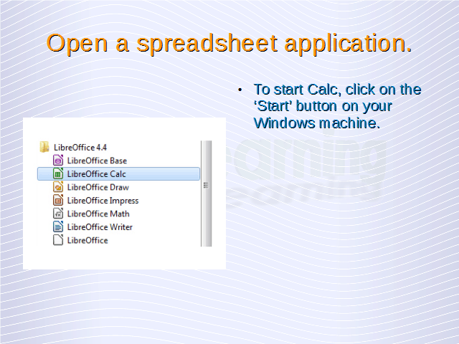

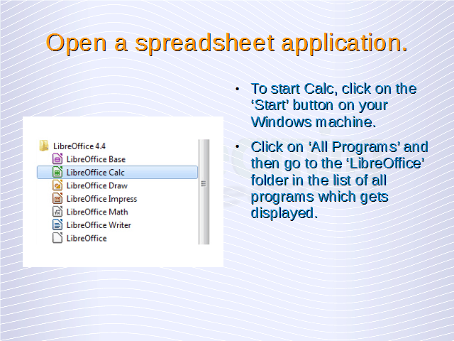

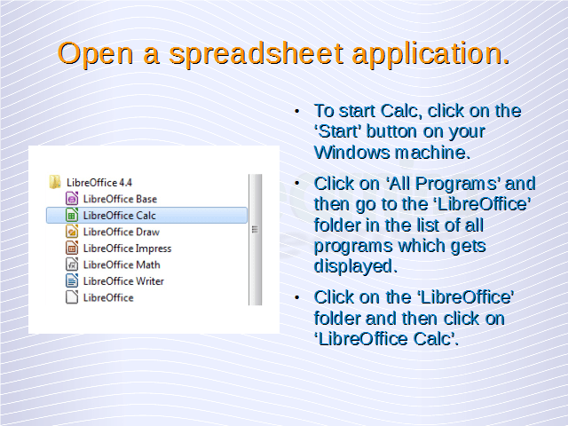

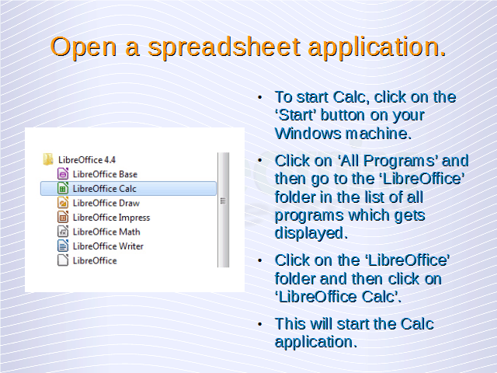

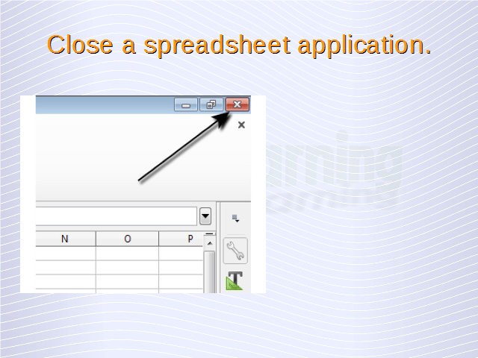

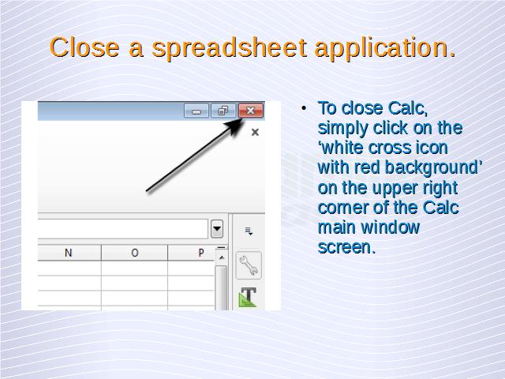

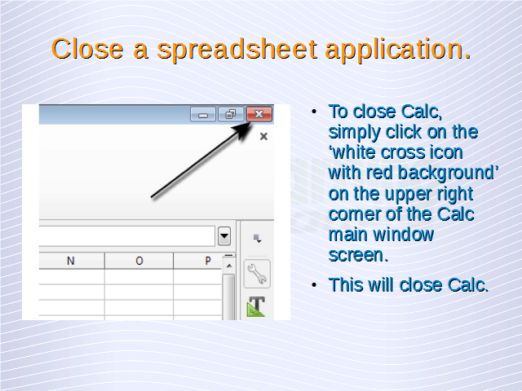



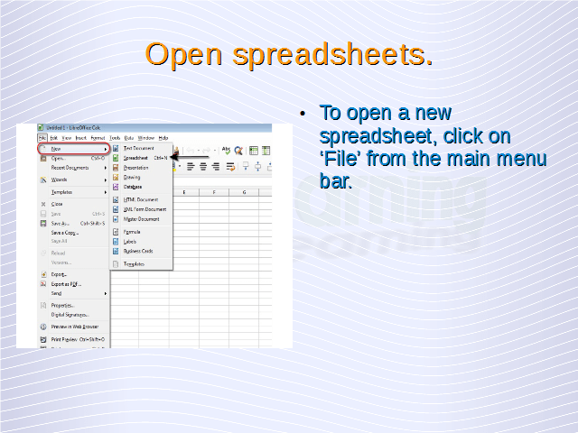

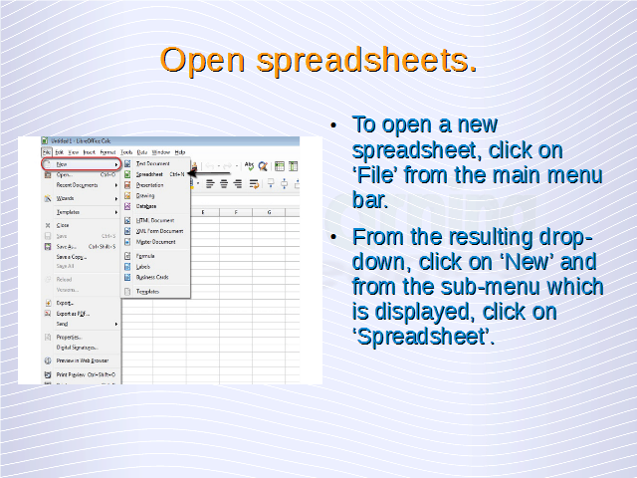

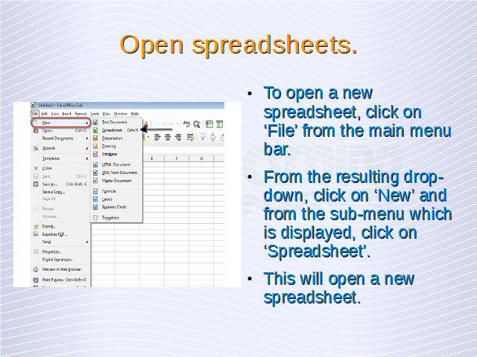

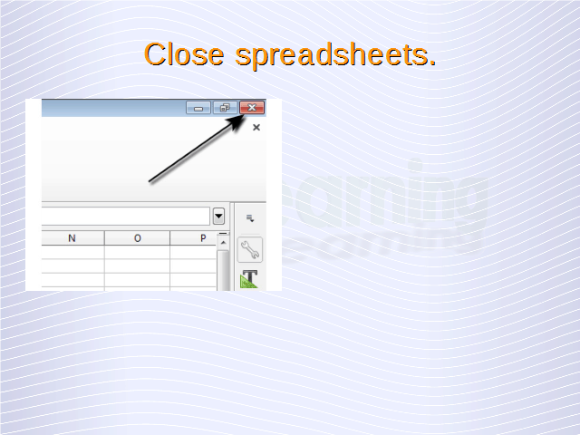

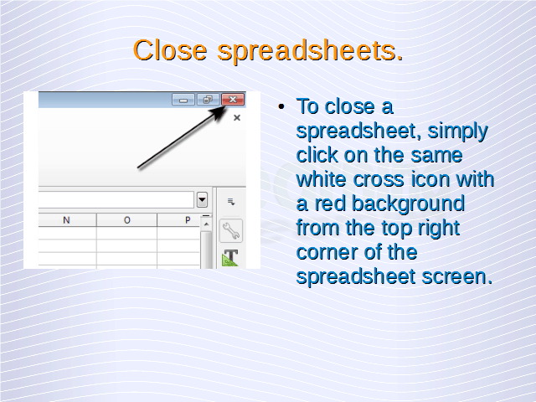

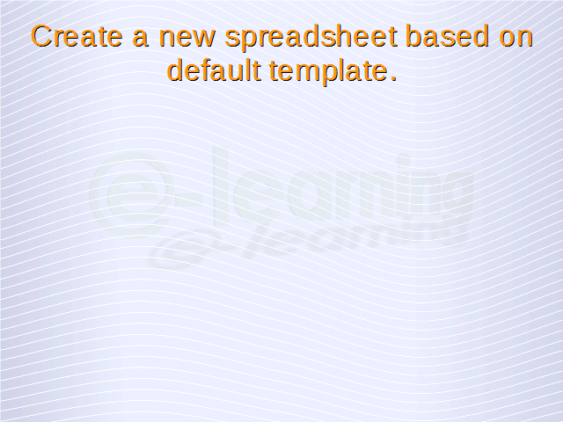

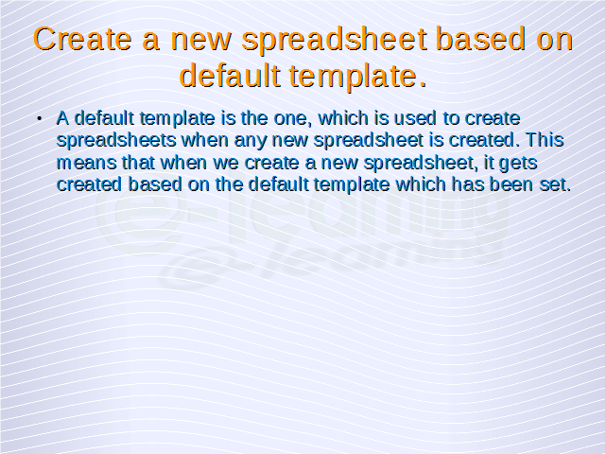



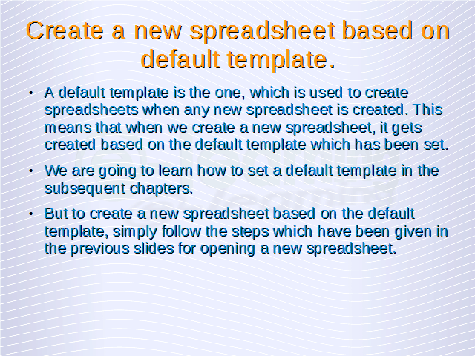

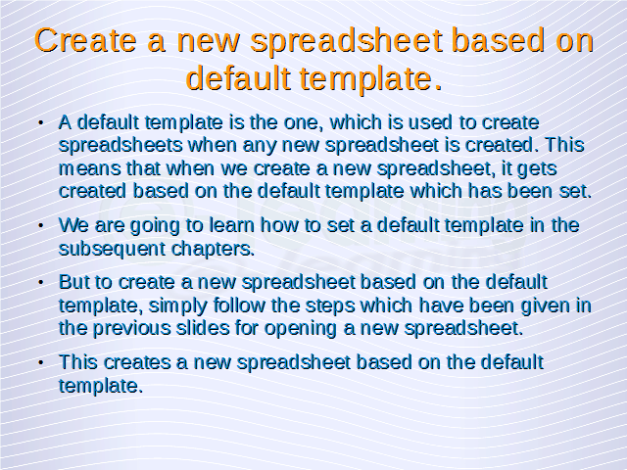

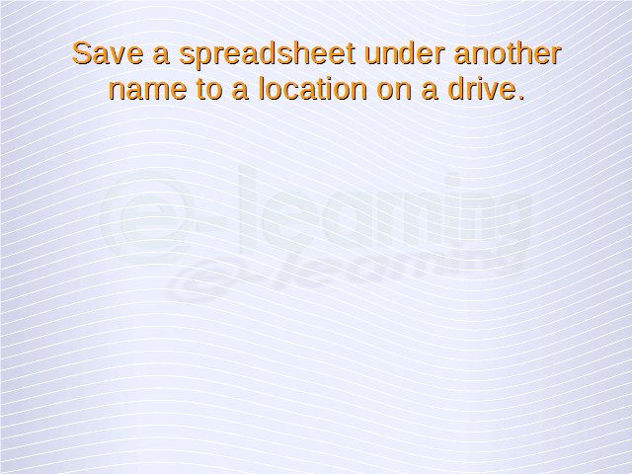

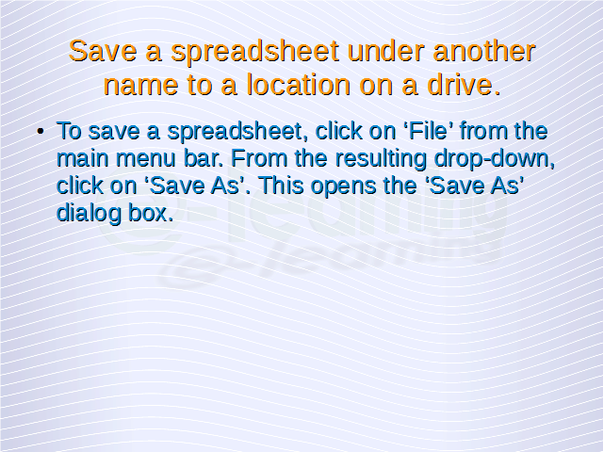

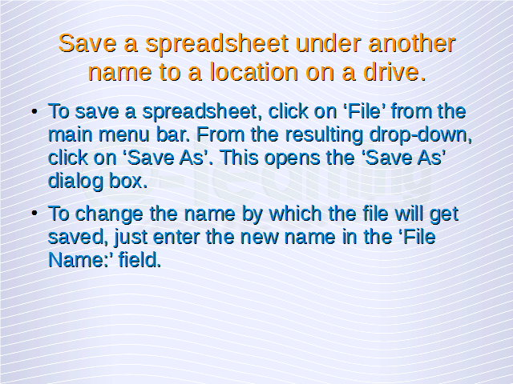

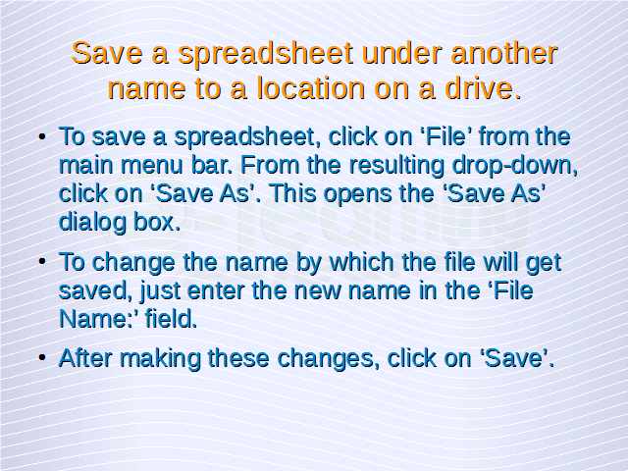

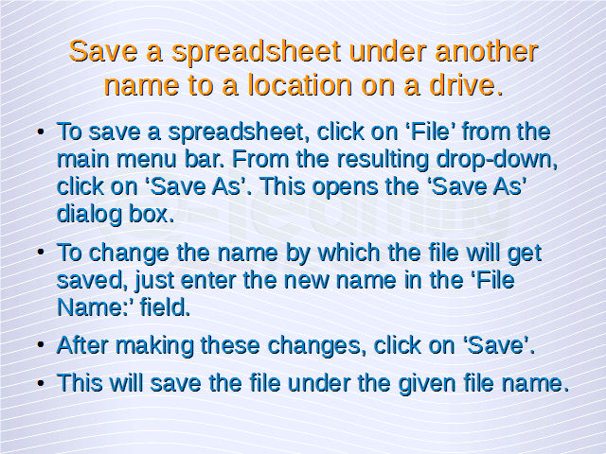

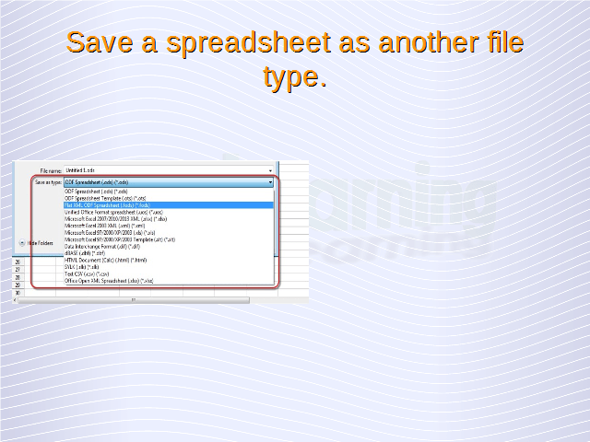

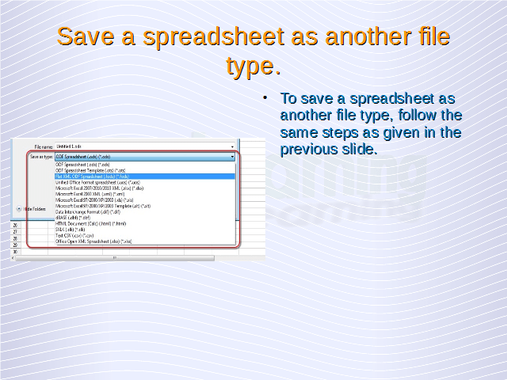

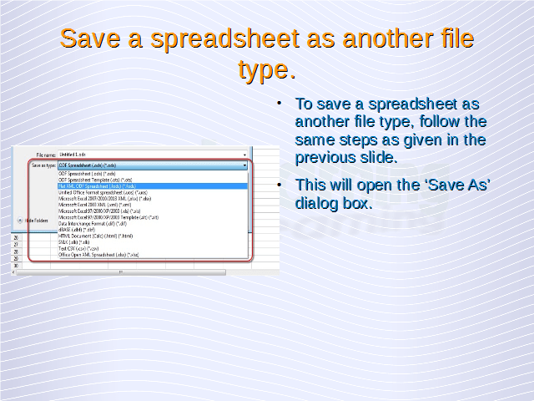

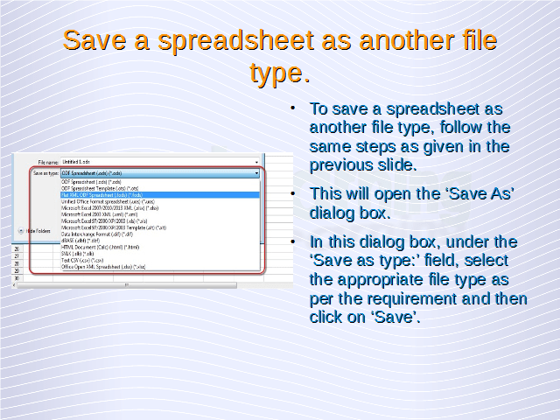

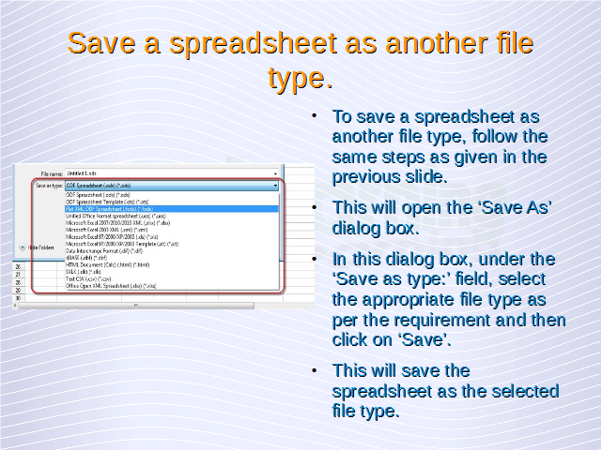

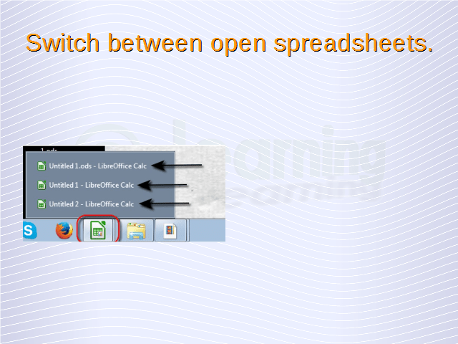

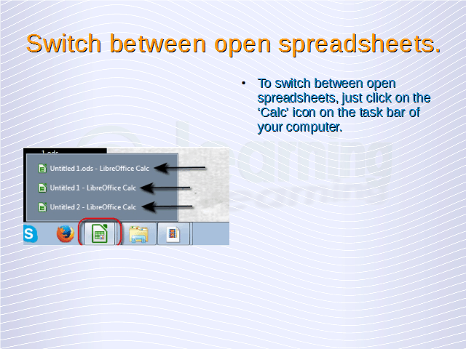

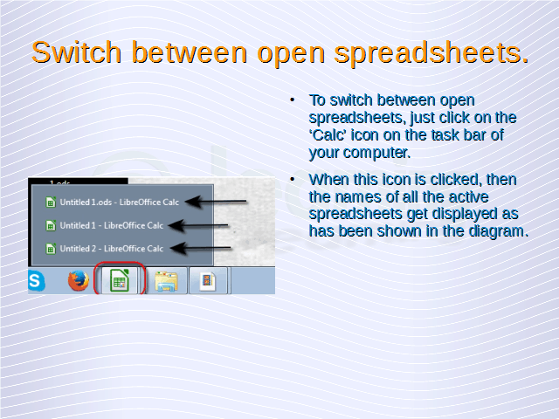

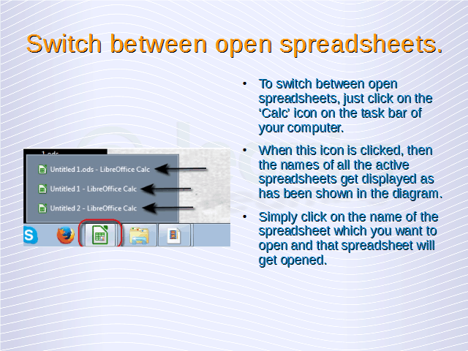

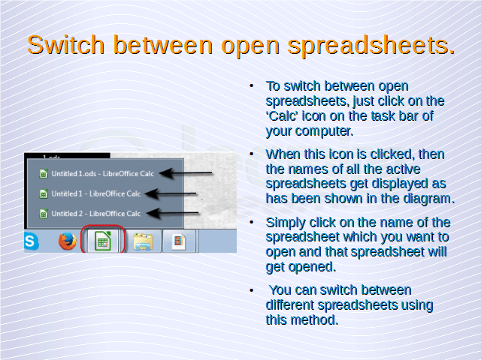

1. [1](https://www.free-online-training-courses.com/working-with-spreadsheets/)
2. [2](https://www.free-online-training-courses.com/working-with-spreadsheets/)
3. [3](https://www.free-online-training-courses.com/working-with-spreadsheets/)
4. [4](https://www.free-online-training-courses.com/working-with-spreadsheets/)
5. [5](https://www.free-online-training-courses.com/working-with-spreadsheets/)
6. [6](https://www.free-online-training-courses.com/working-with-spreadsheets/)
7. [7](https://www.free-online-training-courses.com/working-with-spreadsheets/)
8. [8](https://www.free-online-training-courses.com/working-with-spreadsheets/)
9. [9](https://www.free-online-training-courses.com/working-with-spreadsheets/)
10. [10](https://www.free-online-training-courses.com/working-with-spreadsheets/)
11. [11](https://www.free-online-training-courses.com/working-with-spreadsheets/)
12. [12](https://www.free-online-training-courses.com/working-with-spreadsheets/)
13. [13](https://www.free-online-training-courses.com/working-with-spreadsheets/)
14. [14](https://www.free-online-training-courses.com/working-with-spreadsheets/)
15. [15](https://www.free-online-training-courses.com/working-with-spreadsheets/)
16. [16](https://www.free-online-training-courses.com/working-with-spreadsheets/)
17. [17](https://www.free-online-training-courses.com/working-with-spreadsheets/)
18. [18](https://www.free-online-training-courses.com/working-with-spreadsheets/)
19. [19](https://www.free-online-training-courses.com/working-with-spreadsheets/)
20. [20](https://www.free-online-training-courses.com/working-with-spreadsheets/)
21. [21](https://www.free-online-training-courses.com/working-with-spreadsheets/)
22. [22](https://www.free-online-training-courses.com/working-with-spreadsheets/)
23. [23](https://www.free-online-training-courses.com/working-with-spreadsheets/)
24. [24](https://www.free-online-training-courses.com/working-with-spreadsheets/)
25. [25](https://www.free-online-training-courses.com/working-with-spreadsheets/)
26. [26](https://www.free-online-training-courses.com/working-with-spreadsheets/)
27. [27](https://www.free-online-training-courses.com/working-with-spreadsheets/)
28. [28](https://www.free-online-training-courses.com/working-with-spreadsheets/)
29. [29](https://www.free-online-training-courses.com/working-with-spreadsheets/)
30. [30](https://www.free-online-training-courses.com/working-with-spreadsheets/)
31. [31](https://www.free-online-training-courses.com/working-with-spreadsheets/)
32. [32](https://www.free-online-training-courses.com/working-with-spreadsheets/)
33. [33](https://www.free-online-training-courses.com/working-with-spreadsheets/)
34. [34](https://www.free-online-training-courses.com/working-with-spreadsheets/)
35. [35](https://www.free-online-training-courses.com/working-with-spreadsheets/)

* [Previous](https://www.free-online-training-courses.com/working-with-spreadsheets/)
* [Next](https://www.free-online-training-courses.com/working-with-spreadsheets/)

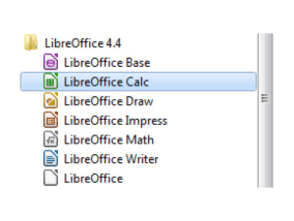

When Calc is started, the main window opens which has been shown below.

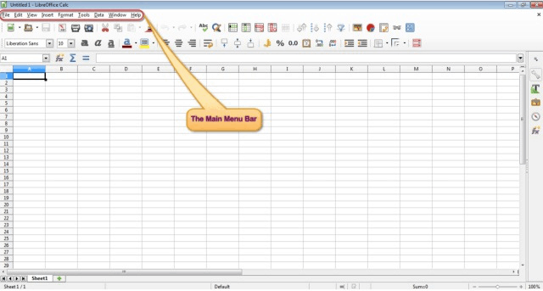

The highlighted portion shown in the above illustration is the ‘Main Menu Bar’. This is the most important menu bar in the Calc application and most of the operations in Calc can be performed from here. In this tutorial, we are going to use the main menu bar for performing a variety of different operations.  
To close Calc, simply click on the ‘white cross icon with red background’ on the upper right corner of the Calc main window screen. This will close Calc.

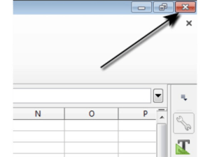

Once the application has been started, then a new spreadsheet can be opened. To open a new spreadsheet, click on ‘File’ from the main menu bar. From the resulting drop-down, click on ‘New’ and from the sub-menu which is displayed, click on ‘Spreadsheet’. This will open a new spreadsheet.

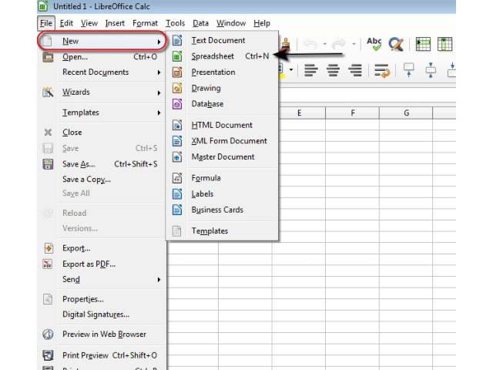

To close a spreadsheet, simply click on the same white cross icon with a red background from the top right corner of the spreadsheet screen.

**Create a new spreadsheet based on default template.**

A default template is the one, which is used to create spreadsheets when any new spreadsheet is created. This means that when we create a new spreadsheet, it gets created based on the default template which has been set.

We are going to learn how to set a default template in the subsequent chapters. But to create a new spreadsheet based on the default template, simply follow the steps which have been given in the last section for opening a new spreadsheet. This creates a new spreadsheet based on the default template.

**Save a spreadsheet to a location on a drive. Save a spreadsheet under another name to a location on a drive.**

Once the changes to a spreadsheet have been made, we need to save this spreadsheet to a location on our computer. To save a spreadsheet, click on ‘File’ from the main menu bar. From the resulting drop-down, click on ‘Save As’. This opens the ‘Save As’ dialog box.

In this dialog box, we can browse to the folder where we want to save the spreadsheet file and thus select the appropriate location. To change the name by which the file will get saved, just enter the new name in the ‘File Name:’ field. After making these changes, click on ‘Save’. This will save the file to the location which has been specified and under the given file name.

**Save a spreadsheet as another file type like: template, text file, software specific file extension, version number.**

To save a spreadsheet as another file type, follow the same steps as given above. This will open the ‘Save As’ dialog box. In this dialog box, under the ‘Save as type:’ field, select the appropriate file type as per the requirement and then click on ‘Save’. This will save the spreadsheet as the selected file type.

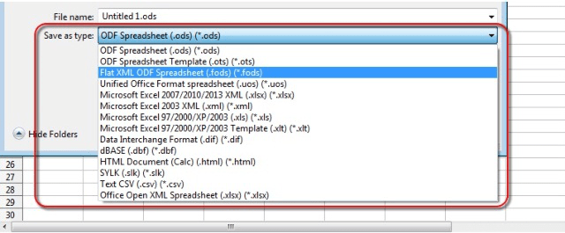

**Switch between open spreadsheets.**

You can open multiple spreadsheets at a time in Calc. In such a case, to switch between these spreadsheets, just click on the ‘Calc’ icon on the task bar of your computer. This icon will always get displayed whenever you are running Calc on your machine.

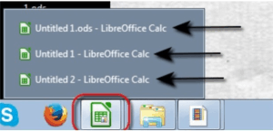When this icon is clicked, then the names of all the active spreadsheets get displayed as has been shown above. Simply click on the name of the spreadsheet which you want to open and that spreadsheet will get opened. You can switch between different spreadsheets using this method.

**Post navigation**

[**Enhancing Productivity**→](https://www.free-online-training-courses.com/enhancing-productivity/)

**Comments**

***Working with Spreadsheets* — 1,461 Comments**

**Comment navigation**

[**← Older Comments**](https://www.free-online-training-courses.com/working-with-spreadsheets/comment-page-70/#comments)

1. muyomba kenneth kizito on [April 25, 2018 at 6:06 am](https://www.free-online-training-courses.com/working-with-spreadsheets/comment-page-71/#comment-870252) said:

thanks for the tutorials on spreadsheets.

[Reply ↓](https://www.free-online-training-courses.com/working-with-spreadsheets/?replytocom=870252#respond)

1. [jabess](http://google/) on [April 24, 2018 at 6:08 pm](https://www.free-online-training-courses.com/working-with-spreadsheets/comment-page-71/#comment-870215) said:

Thanks for a nice and helping lesson.

[Reply ↓](https://www.free-online-training-courses.com/working-with-spreadsheets/?replytocom=870215#respond)

1. Shem on [April 24, 2018 at 3:27 pm](https://www.free-online-training-courses.com/working-with-spreadsheets/comment-page-71/#comment-870204) said:

Thanks, an interesting lesson

[Reply ↓](https://www.free-online-training-courses.com/working-with-spreadsheets/?replytocom=870204#respond)

1. Emmanuel Baptist Peter Mawa on [April 24, 2018 at 10:58 am](https://www.free-online-training-courses.com/working-with-spreadsheets/comment-page-71/#comment-870183) said:

Great I have Achieved many things in this lesson, how to start with the spreadsheet to close, create new spreadsheet and to save to folder, I am so interesting and hoping to achieved more. thank you very much.

[Reply ↓](https://www.free-online-training-courses.com/working-with-spreadsheets/?replytocom=870183#respond)

1. [BOTH](http://nai/) on [April 24, 2018 at 9:38 am](https://www.free-online-training-courses.com/working-with-spreadsheets/comment-page-71/#comment-870177) said:

thank a lot for the lesson.

[Reply ↓](https://www.free-online-training-courses.com/working-with-spreadsheets/?replytocom=870177#respond)

1. Caroline on [April 24, 2018 at 9:37 am](https://www.free-online-training-courses.com/working-with-spreadsheets/comment-page-71/#comment-870176) said:

Thank you sir for the great lesson

[Reply ↓](https://www.free-online-training-courses.com/working-with-spreadsheets/?replytocom=870176#respond)

1. Tamba on [April 24, 2018 at 9:33 am](https://www.free-online-training-courses.com/working-with-spreadsheets/comment-page-71/#comment-870175) said:

The lesson is thoughtful thanks for given me this opportunity

[Reply ↓](https://www.free-online-training-courses.com/working-with-spreadsheets/?replytocom=870175#respond)

1. manyot biey on [April 24, 2018 at 1:18 am](https://www.free-online-training-courses.com/working-with-spreadsheets/comment-page-71/#comment-870156) said:

this training is every very good training now I am interest with it.

[Reply ↓](https://www.free-online-training-courses.com/working-with-spreadsheets/?replytocom=870156#respond)

1. Emi Ratu on [April 24, 2018 at 12:29 am](https://www.free-online-training-courses.com/working-with-spreadsheets/comment-page-71/#comment-870153) said:

Interesting and thank you!!

[Reply ↓](https://www.free-online-training-courses.com/working-with-spreadsheets/?replytocom=870153#respond)

1. Martin ARUNA on [April 23, 2018 at 2:35 pm](https://www.free-online-training-courses.com/working-with-spreadsheets/comment-page-71/#comment-870108) said:

The lesson interest me more to continue complying with you sir.Thank you very much!

[Reply ↓](https://www.free-online-training-courses.com/working-with-spreadsheets/?replytocom=870108#respond)

1. [Dennis Kollie](http://google/) on [April 23, 2018 at 1:10 pm](https://www.free-online-training-courses.com/working-with-spreadsheets/comment-page-71/#comment-870098) said:

Thanks again for your impressive lesson

[Reply ↓](https://www.free-online-training-courses.com/working-with-spreadsheets/?replytocom=870098#respond)

1. [Samuel](http://www.sopokuagyemang98@gmail.com/) on [April 23, 2018 at 11:23 am](https://www.free-online-training-courses.com/working-with-spreadsheets/comment-page-71/#comment-870080) said:

Very good and impressive lesson tutor,thank you so much.

[Reply ↓](https://www.free-online-training-courses.com/working-with-spreadsheets/?replytocom=870080#respond)

1. Abraham on [April 23, 2018 at 10:54 am](https://www.free-online-training-courses.com/working-with-spreadsheets/comment-page-71/#comment-870077) said:

Grateful for the lesson. its much educative.

[Reply ↓](https://www.free-online-training-courses.com/working-with-spreadsheets/?replytocom=870077#respond)

1. Kaande on [April 22, 2018 at 11:12 pm](https://www.free-online-training-courses.com/working-with-spreadsheets/comment-page-71/#comment-870034) said:

Thank you for the great lesson, its so interesting

[Reply ↓](https://www.free-online-training-courses.com/working-with-spreadsheets/?replytocom=870034#respond)

1. Bob Chris Ogwal on [April 22, 2018 at 8:42 pm](https://www.free-online-training-courses.com/working-with-spreadsheets/comment-page-71/#comment-870022) said:

Thanks So Much!!, Let’s get going.

[Reply ↓](https://www.free-online-training-courses.com/working-with-spreadsheets/?replytocom=870022#respond)

**Comment navigation**

[**← Older Comments**](https://www.free-online-training-courses.com/working-with-spreadsheets/comment-page-70/#comments)

**Leave a Reply**

Top of Form

Your email address will not be published. Required fields are marked **\***

Comment 

Name **\*** 

Email **\*** 

Website 



Bottom of Form

https://www.google.com/images/cleardot.gif[Select Language[https://www.google.com/images/cleardot.gif](javascript:void(0))​[https://www.google.com/images/cleardot.gif](javascript:void(0))▼](javascript:void(0))

**Find That Lesson With Google Search**

Top of Form



Bottom of Form

Google

Custom Search

**New Courses**

[https://www.feedburner.com/fb/images/pub/feed-icon16x16.png](http://feeds.feedburner.com/FreeOnlineTrainingCourses) [Subscribe in a reader](http://feeds.feedburner.com/FreeOnlineTrainingCourses)

**Latest Lessons**

* [Advanced Database – Link external data to a database: spreadsheet](https://www.free-online-training-courses.com/advanced-database-link-external-data-to-a-database-spreadsheet/)
* [Understanding Databases – Force page breaks for groups in a report](https://www.free-online-training-courses.com/understanding-databases-force-page-breaks-for-groups-in-a-report/)
* [Advanced Databases – Sort, group records in a report by field(s)](https://www.free-online-training-courses.com/advanced-databases-sort-group-records-in-a-report-by-fields/)
* [Advanced Databases – Insert, delete a data field in group, page, report headers and footers.](https://www.free-online-training-courses.com/advanced-databases-insert-delete-a-data-field-in-group-page-report-headers-and-footers/)
* [Advanced Databases – Concatenate fields in a report.](https://www.free-online-training-courses.com/advanced-databases-concatenate-fields-in-a-report/)

**Available Courses**

* [Customising Your PC](https://www.free-online-training-courses.com/category/customising-your-pc/) (5)
* [IT Training](https://www.free-online-training-courses.com/category/it-training/) (12)
* [Learn Computer Skills](https://www.free-online-training-courses.com/category/learn-computer-skills/) (25)
  + [Basic Computer Skills](https://www.free-online-training-courses.com/category/learn-computer-skills/basic-computer-skills/) (12)
  + [Common Tasks](https://www.free-online-training-courses.com/category/learn-computer-skills/common-tasks/) (8)
  + [Intermediate Computer Skills](https://www.free-online-training-courses.com/category/learn-computer-skills/intermediate-computer-skills/) (5)
* [Microsoft Certified Professional](https://www.free-online-training-courses.com/category/mcp/) (79)
  + [Disaster Recovery](https://www.free-online-training-courses.com/category/mcp/disaster-recovery/) (5)
  + [Hardware](https://www.free-online-training-courses.com/category/mcp/hardware/) (5)
  + [Installations](https://www.free-online-training-courses.com/category/mcp/installations/) (1)
  + [Interoperability](https://www.free-online-training-courses.com/category/mcp/interoperability/) (3)
  + [Introduction To Networking](https://www.free-online-training-courses.com/category/mcp/networking/)(25)
    - [Managing Disks](https://www.free-online-training-courses.com/category/mcp/networking/managing-disks/) (9)
    - [Windows Quickstart](https://www.free-online-training-courses.com/category/mcp/networking/windows/) (8)
    - [Windows XP Server 2003](https://www.free-online-training-courses.com/category/mcp/networking/xpserver2003/)(8)
  + [Local Security](https://www.free-online-training-courses.com/category/mcp/local-security/) (6)
  + [Local Users and Groups](https://www.free-online-training-courses.com/category/mcp/local-users-and-groups/) (4)
  + [Monitoring and Optimisation](https://www.free-online-training-courses.com/category/mcp/monitoring-and-optimisation/)(5)
  + [NTFS](https://www.free-online-training-courses.com/category/mcp/ntfs/) (4)
  + [Printing](https://www.free-online-training-courses.com/category/mcp/printing/) (3)
  + [Remote Desktop and Terminal Services](https://www.free-online-training-courses.com/category/mcp/remote-desktop-and-terminal-services/) (6)
  + [Shared Folders](https://www.free-online-training-courses.com/category/mcp/shared-folders/) (5)
  + [TCP/IP](https://www.free-online-training-courses.com/category/mcp/tcpip/) (7)
* [Microsoft Certified Systems Engineer](https://www.free-online-training-courses.com/category/microsoft-certified-systems-engineer/) (86)
  + [Active Directory Overview](https://www.free-online-training-courses.com/category/microsoft-certified-systems-engineer/active-directory-overview/)(8)
  + [Active Directory Sites And Replication](https://www.free-online-training-courses.com/category/microsoft-certified-systems-engineer/active-directory-sites-and-replication-microsoft-certified-systems-engineer/) (5)
  + [Active Directory Trusts](https://www.free-online-training-courses.com/category/microsoft-certified-systems-engineer/active-directory-trusts-microsoft-certified-systems-engineer/) (2)
  + [Active Directory Users and Groups](https://www.free-online-training-courses.com/category/microsoft-certified-systems-engineer/active-directory-users-and-groups/) (4)
  + [Certificate Services](https://www.free-online-training-courses.com/category/microsoft-certified-systems-engineer/certificate-services/) (6)
  + [Deploying Applications](https://www.free-online-training-courses.com/category/microsoft-certified-systems-engineer/deploying-applications/) (3)
  + [DFS](https://www.free-online-training-courses.com/category/microsoft-certified-systems-engineer/dfs/) (5)
  + [DHCP](https://www.free-online-training-courses.com/category/microsoft-certified-systems-engineer/dhcp/) (5)
  + [DNS](https://www.free-online-training-courses.com/category/microsoft-certified-systems-engineer/configuring-name-resolution/) (8)
  + [Group Policy](https://www.free-online-training-courses.com/category/microsoft-certified-systems-engineer/group-policy-microsoft-certified-systems-engineer/) (5)
  + [IIS](https://www.free-online-training-courses.com/category/microsoft-certified-systems-engineer/iis/) (5)
  + [IPsec](https://www.free-online-training-courses.com/category/microsoft-certified-systems-engineer/ipsec/) (3)
  + [Remote Access](https://www.free-online-training-courses.com/category/microsoft-certified-systems-engineer/remote-access/) (6)
  + [RIS](https://www.free-online-training-courses.com/category/microsoft-certified-systems-engineer/ris/) (7)
  + [Routing](https://www.free-online-training-courses.com/category/microsoft-certified-systems-engineer/routing/) (6)
  + [SUS](https://www.free-online-training-courses.com/category/microsoft-certified-systems-engineer/sus/) (3)
  + [WINS](https://www.free-online-training-courses.com/category/microsoft-certified-systems-engineer/wins/) (6)
* [Microsoft Certified Technology Specialist](https://www.free-online-training-courses.com/category/microsoft-certified-technology-specialist/) (129)
  + [Windows Server 2008 Active Directory, Configuring](https://www.free-online-training-courses.com/category/microsoft-certified-technology-specialist/windows-server-2008-active-directory-configuring/)(78)
    - [Active Directory Federation Services](https://www.free-online-training-courses.com/category/microsoft-certified-technology-specialist/windows-server-2008-active-directory-configuring/active-directory-federation-services/) (3)
    - [Active Directory Rights Management](https://www.free-online-training-courses.com/category/microsoft-certified-technology-specialist/windows-server-2008-active-directory-configuring/active-directory-rights-management/) (3)
    - [Active Directory Sites And Replication](https://www.free-online-training-courses.com/category/microsoft-certified-technology-specialist/windows-server-2008-active-directory-configuring/active-directory-sites-and-replication/) (3)
    - [Active Directory Trusts](https://www.free-online-training-courses.com/category/microsoft-certified-technology-specialist/windows-server-2008-active-directory-configuring/active-directory-trusts/) (2)
    - [Administration](https://www.free-online-training-courses.com/category/microsoft-certified-technology-specialist/windows-server-2008-active-directory-configuring/administration/) (5)
    - [Authentication](https://www.free-online-training-courses.com/category/microsoft-certified-technology-specialist/windows-server-2008-active-directory-configuring/authentication/) (5)
    - [Certificate Services](https://www.free-online-training-courses.com/category/microsoft-certified-technology-specialist/windows-server-2008-active-directory-configuring/certificate-services-windows-server-2008-active-directory-configuring/) (9)
    - [Computers](https://www.free-online-training-courses.com/category/microsoft-certified-technology-specialist/windows-server-2008-active-directory-configuring/computers/) (4)
    - [Directory Business Continuity](https://www.free-online-training-courses.com/category/microsoft-certified-technology-specialist/windows-server-2008-active-directory-configuring/directory-business-continuity/) (5)
    - [Domain Controllers](https://www.free-online-training-courses.com/category/microsoft-certified-technology-specialist/windows-server-2008-active-directory-configuring/domain-controllers/) (4)
    - [Group Policy](https://www.free-online-training-courses.com/category/microsoft-certified-technology-specialist/windows-server-2008-active-directory-configuring/group-policy/) (4)
    - [Groups](https://www.free-online-training-courses.com/category/microsoft-certified-technology-specialist/windows-server-2008-active-directory-configuring/groups/) (6)
    - [Installation](https://www.free-online-training-courses.com/category/microsoft-certified-technology-specialist/windows-server-2008-active-directory-configuring/installation/) (5)
    - [Integrating Domain Name System](https://www.free-online-training-courses.com/category/microsoft-certified-technology-specialist/windows-server-2008-active-directory-configuring/integrating-domain-name-system/) (6)
    - [Lightweight Directory Services](https://www.free-online-training-courses.com/category/microsoft-certified-technology-specialist/windows-server-2008-active-directory-configuring/lightweight-directory-services/) (2)
    - [Users](https://www.free-online-training-courses.com/category/microsoft-certified-technology-specialist/windows-server-2008-active-directory-configuring/users/) (9)
  + [Windows Server 2008 Network Infrastructure, Configuring](https://www.free-online-training-courses.com/category/microsoft-certified-technology-specialist/windows-server-2008-network-infrastructure-configuring/) (59)
    - [Configuring IP Routing](https://www.free-online-training-courses.com/category/microsoft-certified-technology-specialist/windows-server-2008-network-infrastructure-configuring/configuring-ip-routing/) (4)
    - [Configuring Name Resolution](https://www.free-online-training-courses.com/category/microsoft-certified-technology-specialist/windows-server-2008-network-infrastructure-configuring/configuring-name-resolution-windows-server-2008-network-infrastructure-configuring/) (8)
    - [Configuring Windows Firewall and Network Access Protection](https://www.free-online-training-courses.com/category/microsoft-certified-technology-specialist/windows-server-2008-network-infrastructure-configuring/configuring-windows-firewall-and-network-access-protection/) (4)
    - [Connect To A Network](https://www.free-online-training-courses.com/category/microsoft-certified-technology-specialist/windows-server-2008-network-infrastructure-configuring/connect-to-a-network/) (6)
    - [Creating a DHCP Infrastructure](https://www.free-online-training-courses.com/category/microsoft-certified-technology-specialist/windows-server-2008-network-infrastructure-configuring/creating-a-dhcp-infrastructure/) (5)
    - [Managing Files](https://www.free-online-training-courses.com/category/microsoft-certified-technology-specialist/windows-server-2008-network-infrastructure-configuring/managing-files/) (11)
    - [Managing Printers](https://www.free-online-training-courses.com/category/microsoft-certified-technology-specialist/windows-server-2008-network-infrastructure-configuring/managing-printers/) (3)
    - [Managing Software Updates](https://www.free-online-training-courses.com/category/microsoft-certified-technology-specialist/windows-server-2008-network-infrastructure-configuring/managing-software-updates/) (4)
    - [Monitoring Computers](https://www.free-online-training-courses.com/category/microsoft-certified-technology-specialist/windows-server-2008-network-infrastructure-configuring/monitoring-computers/) (4)
    - [Protecting Network traffic with IPSec](https://www.free-online-training-courses.com/category/microsoft-certified-technology-specialist/windows-server-2008-network-infrastructure-configuring/protecting-network-traffic-with-ipsec/) (3)
    - [TCP/IP](https://www.free-online-training-courses.com/category/microsoft-certified-technology-specialist/windows-server-2008-network-infrastructure-configuring/tcpip-windows-server-2008-network-infrastructure-configuring-microsoft-certified-technology-specialist/) (7)
* [Office Software](https://www.free-online-training-courses.com/category/office-software/) (280)
  + [LibreOffice](https://www.free-online-training-courses.com/category/office-software/libreoffice/) (278)
    - [Advanced Database](https://www.free-online-training-courses.com/category/office-software/libreoffice/advanced-database/) (47)
    - [Advanced Presentations](https://www.free-online-training-courses.com/category/office-software/libreoffice/advanced-presentation/)(25)
    - [Advanced Spreadsheets](https://www.free-online-training-courses.com/category/office-software/libreoffice/advanced-spreadsheets/)(47)
    - [Advanced Word Processing](https://www.free-online-training-courses.com/category/office-software/libreoffice/advanced-word-processing/) (38)
    - [Base](https://www.free-online-training-courses.com/category/office-software/libreoffice/base/) (29)
    - [Calc](https://www.free-online-training-courses.com/category/office-software/libreoffice/calc/) (20)
    - [Math](https://www.free-online-training-courses.com/category/office-software/libreoffice/math/) (16)
    - [Presentations](https://www.free-online-training-courses.com/category/office-software/libreoffice/presentations/) (33)
    - [Writer](https://www.free-online-training-courses.com/category/office-software/libreoffice/writer/) (22)
      * [Mail Merge](https://www.free-online-training-courses.com/category/office-software/libreoffice/writer/mail-merge/) (3)
* [Uncategorized](https://www.free-online-training-courses.com/category/uncategorized/) (1)
* [Website Design](https://www.free-online-training-courses.com/category/website-design/) (22)
  + [Creating websites with HTML](https://www.free-online-training-courses.com/category/website-design/creating-websites-with-html/) (9)
  + [CSS](https://www.free-online-training-courses.com/category/website-design/css/) (6)
  + [Extras](https://www.free-online-training-courses.com/category/website-design/extras/) (3)
  + [What is the internet](https://www.free-online-training-courses.com/category/website-design/what-is-the-internet/) (4)
* [Windows Maintenance](https://www.free-online-training-courses.com/category/windows-maintenance/) (9)
* [Wordpress](https://www.free-online-training-courses.com/category/wordpress/) (12)
* [Terms and Conditions](https://www.free-online-training-courses.com/terms-conditions/)
* [Privacy Policy](https://www.free-online-training-courses.com/privacy-policy/)
* [Site Map](https://www.free-online-training-courses.com/sitemap/)

©2018 - [The Place For Free Online Training Courses](https://www.free-online-training-courses.com/)

Free Online Training Courses Uses Cookies[learn more](https://www.free-online-training-courses.com/privacy-policy/)[close message](https://www.free-online-training-courses.com/working-with-spreadsheets/)